Outdoor Full Color 8-bit Linear Light
-Suitable for outdoor lighting applications of building facades that requires integration with steel structures and fixture completely hidden during the day .

L2-RGB48

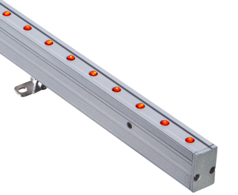
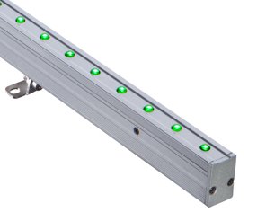
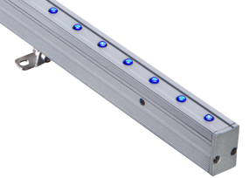
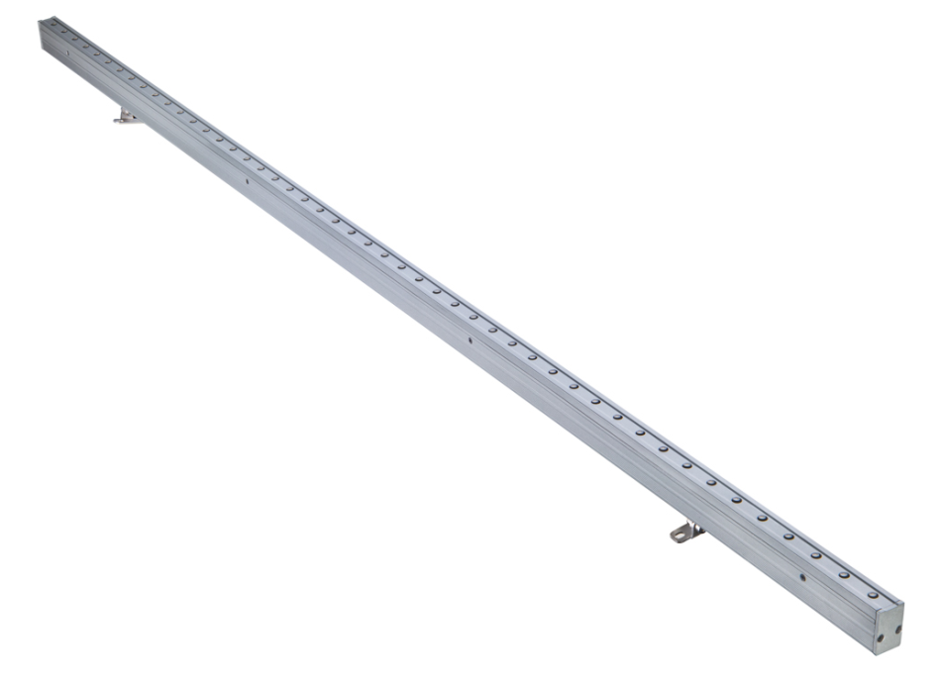
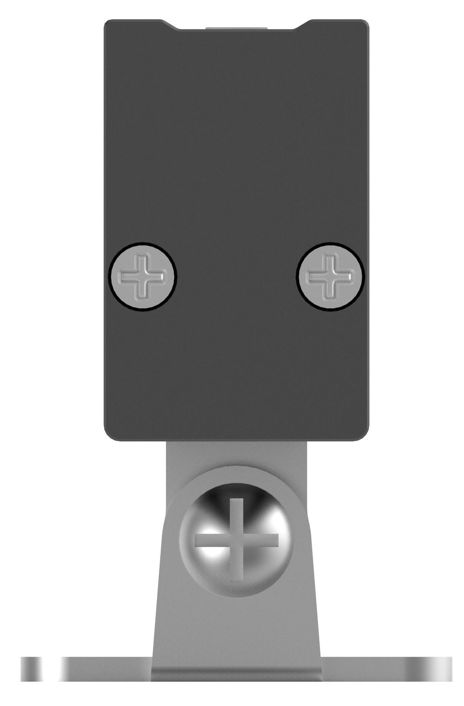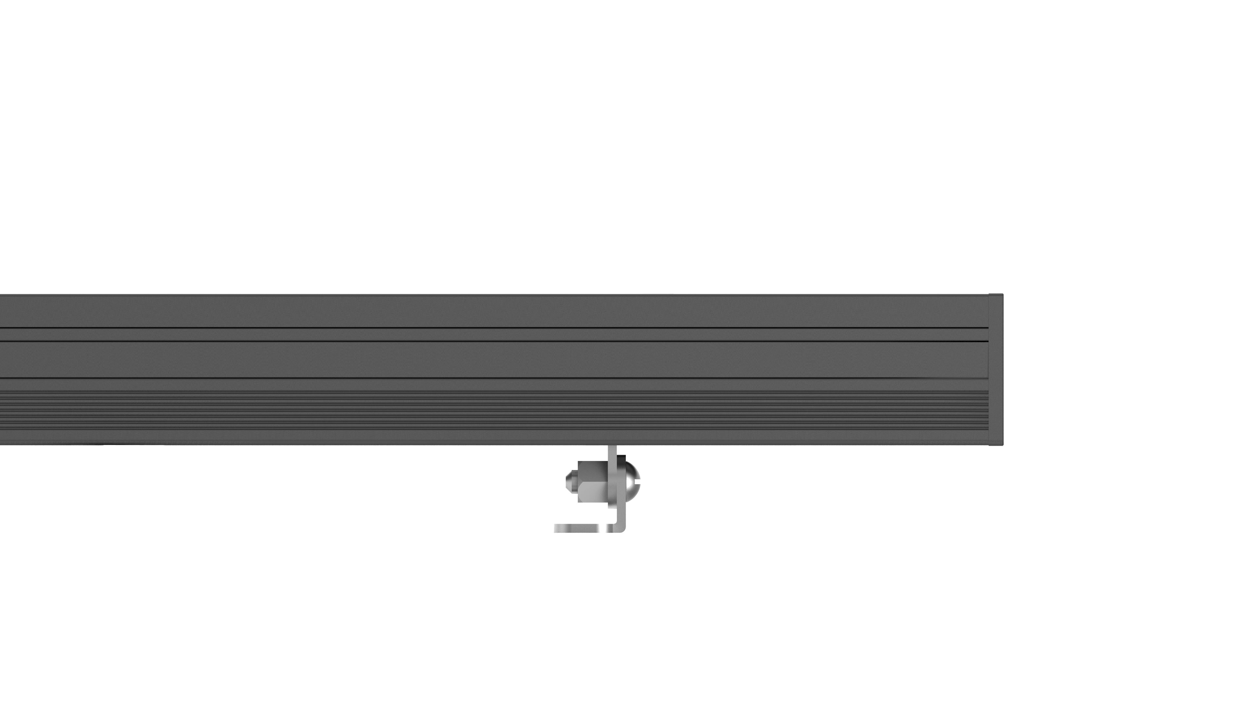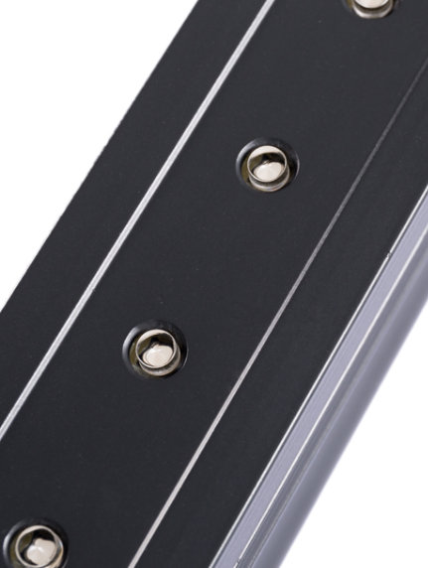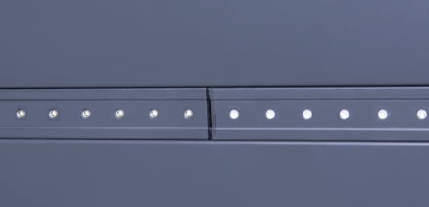
Ultra-narrow shape design
Connection cables that can be hidden
Integration of optical lenses and luminaires
Integration of luminaires and building with seamless splicing of light

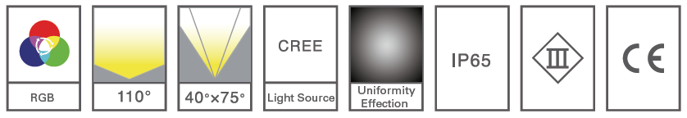
Product Dimensions
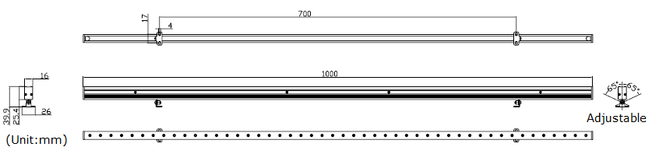
Light Distribution Curve
（RGB full color, beam angle 110°/ full angle 145°） （RGB full color, beam angle 40°*75°/ full angle 95°*125°）
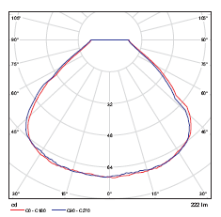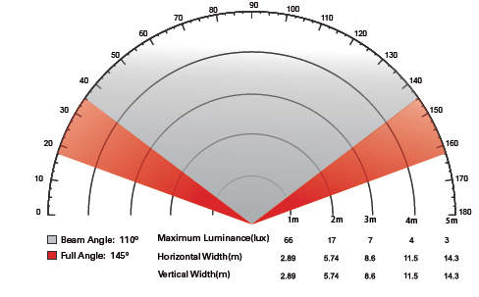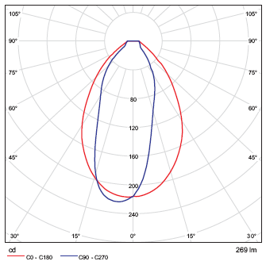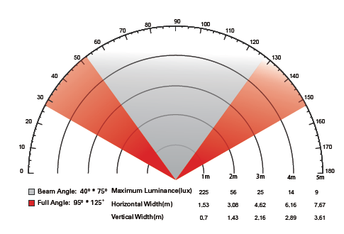
Technical Parameters
Product model | Maximum input power | Luminous flux | Working voltage | Beam angle
PWL2-RGB48-110AR0000-9D24 | 9W | 222lm | DC24V | 110°
PWL2-RGB48-4075AR0000-9D24 | 9W | 269lm | DC24V | 40°*75°

Related Information
Material: Lamp housing: 6063 aviation aluminum
Surface Treatment: Anti-corrosion treatment + 200˚C pyrolytic coating
Housing Color: Gray-black (customizable to building color)
Pixel: 8 bit/meter
Net Weight (kg): 0.72/pcs
Gross Weight (kg): 0.79/pcs
Packing Size (mm): 1070*398*316 （36pcs /carton）
Working Temperature: -35℃～50℃
Storage Temperature: -40℃～70℃



